**The Ex-Machina**

**GAME DESIGN DOCUMENT**

By Vaity and D4ng30nM4sst3r for summer piratejam 2025

**Introduction 2**

**Game Summary Pitch 2**

**Player experience 5**

**Platform 5**

**Development software 6**

**Genre 6**

**Target audience 6**

**Concept 6**

**Gameplay overview 6**

**Primary mechanics 7**

**Secondary mechanics 7**

**Art design 8**

**Audio 8**

**Music 8**

**Sound effects 8**

**Game Experience 8**

**UI 8**

**Controls 8**

**Development Timeline 8**

# Introduction

## Game Summary Pitch

‘The Ex-Machina’ is an action game, where you play as an entity, who controls robots, by controlling robots a player supposed to destroy other robots in an area by taking control over them until only one is left. about being robot and destroy all other robots in the area.

## Inspiration

|  |  |
| --- | --- |
| **S.T.A.L.K.E.R. Call of Chernobyl**  Inside of this modification on the S.T.A.L.K.E.R. Call of Pripyat there are couple of major changes, especially for simulation of NPC’s life. This mod has a mode to play in Azazel Mode which allows you to play as another NPC with its equipment and reputation after your character dies. |  |
| **Armored Core 6**  Third-person mecha-based vehicular combat shooter game by fromsoftware. Huge part of the game is about robot modification, which inspires ‘The Ex-Machina’. |  |

## Player experience

Player as an operator of a drone from Third person have to clear area from other robots. Robot body parts are replaceable and change its functionality depending on a goal to achieve the goal. Even if a robot gets destroyed, if there’s at least one disconnected robot, player would be able to get control over it. By dodging, hiding from scary guns, player can build its own strategy and become the fighter itself

## Platform

The game will be released on Windows, Linux and Web

## Development software

- Godot 4.4

- Blender for 3d modeling

- Photoshop for concepts

- Github version control

- Krita for UI

- Reaper for all music and SFX

## Genre

Single player, Indie, Third person Action, Shooter, Mecha

## Target audience

Utilizing simple to understand mechanics with sandbox direction, the game is oriented on people, who are familiar with shooter-based games

# Concept

## Gameplay overview

Player control a robot, built from different parts, combination of such parts can make unique functionality. Player’s goal is to clear area from all robots despite being in disadvantage by not being able to utilize maximum performance from them.

## Theme Interpretation (Only One)

‘Only one’ interpretation - The player would face multiple options and have only one choice available. Also that would be expressed in game with situations where only one can make it through and\or have only one chance.

As an third-person action game such theme would strictly interpret in the main goal as being the only one survived. Also to make player face multiple options of equipment and tools for achieving your goal and choose only one.

## Primary mechanics

|  |
| --- |
| Mechanic |
| Walking  Player can move in all directions. |
| Camera  Player can view his robot and environment in 3d dimension. |
| Body parts  Equipment for player, which are legs, define movement speed of player’s robot |
| Weapon  If player’s right hand fires, depending on weapon type, on collision with other robot, the robot get damage. It has three types of firing:  scan-hit (the moment it fires the moment it hits); projectile (ordinary shot, fly slow, hit on collision);  Grenade launcher(shoot grenades, explode after a few seconds) |
| Enemy robot  The only hostile being in environment. It can search path toward player, notice player, murder player. Player either has to retreat and come out with a smart strategy or destroy all robots in a heavy fight |
| Reconnect  If there is another connected robot and player’s robot got destroyed, player can continue playing by taking over of other robots up to 2 times. |
| Manipulator  Robots have ‘left hand’ it can customize robot parts. Whenever player get close enough to equipment, they can press ‘action’ button to equip new type of equipment instead of the current one. |

## Secondary mechanics

|  |
| --- |
| Mechanic |
| ~~Crawl~~  ~~If robot last his legs. It will crawl by its manipulator. Hitbox of robot shortens.~~ |
| ~~Bad vision~~  ~~If robots head get destroyed then vision of player become worse. For enemies they could become more confused~~ |
| Boost  Boost to avoid being shoot or to move faster |
| ~~Auto-lock~~  ~~Enemies aim can lock in player model~~ |

# Art design WIP

Low-poly art style with realistic textures to provide a feeling of “retro games” to players.

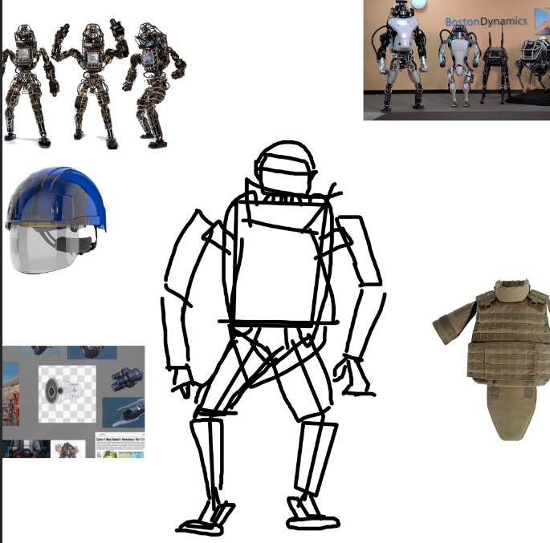

Robot design

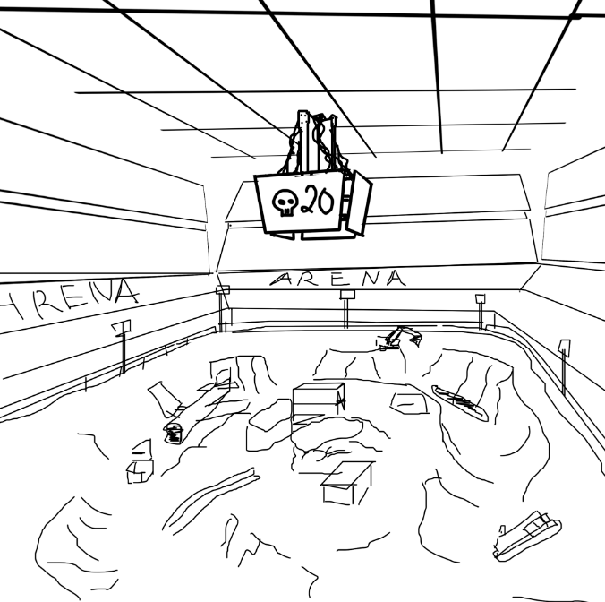

Level concept

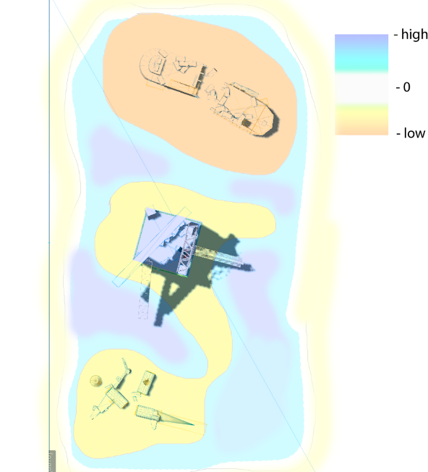

Level layout

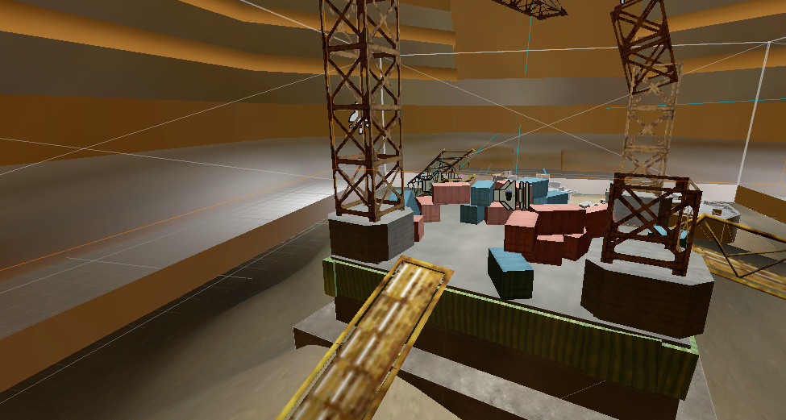

Picture of game environment

# Audio WIP

## Music

Techno\Industrial to give players feel of being in post-modern era where robots can fight along humans without being a burden to them or just a tool.

## Sound effects

To give the game a feeling of completeness, it it necessary to provide sound feedback from environment to the player’s action utilizing “old”-style audio effects and at the same time being close to realism.

# Game Experience

## UI

Boost icon: whenever boost is used,

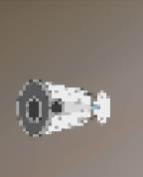

it will display the remaining timeuntil recharge

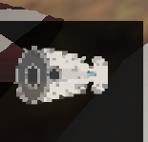

## Controls

**Keyboard**

WASD + mouse

# Development Timeline

|  |  |  |  |  |  |
| --- | --- | --- | --- | --- | --- |
| # | Assignment | Type | Status | Finish by | Notes |
| 1 | Game Design Document | Other | In progress |  |  |
| 2 | Base player controller | Programming | Completed | 19 July 2025 | Very base |
| 3 | 3D modeling | Assets | In progress |  |  |
| 4 | Sound design | Assets | Partially completed | 30 July 2025 |  |
| 5 | Basic Weapon mechanic | Programming | Completed | 22 July 2025 | Base |
| 6 | Enemies mechanics | Programming | Completed | 22 July 2025 | Base |
| 7 | Laser gun | Programming | Completed | 24 July 2025 |  |
| 8 | Ordinary gun | Programming | Completed | 24 July 2025 |  |
| 9 | Rocket gun | Programming | Canceled |  |  |
| 10 | Grenade Launcher | Programming | Completed | 24 July 2025 |  |
| 11 | User Interface | Programming | Partially completed | 31 July 2025 | Highly important |
| 12 | Landscape textures | Assets | Completed | 30 July 2025 |  |
| 13 | Additional mechanics | Programming | In progress |  |  |